2200030216  
week-1 Design patterns and principals   
Exercise-1

Create a project folder

Singletontestexample  
now create a java file  
singletontest.java  
  
public class SingletonTest {

    public static *void* main(*String*[] *args*) {

*Logger* logger1 = Logger.getInstance();

*Logger* logger2 = Logger.getInstance();

        System.out.println("logger1 == logger2 ? " + (logger1 == logger2));  // true

        logger1.log("This is the first log message.");

        logger2.log("This is the second log message.");

    }

}

next Logger.java  
(make it private)  
public final class Logger {

    private static final Logger INSTANCE = new Logger();

    private Logger() {

        System.out.println("Logger initialized.");

    }

    public static Logger getInstance() {

        return INSTANCE;

    }

    public *void* log(String *message*) {

        System.out.println("[LOG] " + *message*);

    }

}

now you run the main java file that is singletontest.java  
you get this  
Logger initialized.

logger1 == logger2 ? true

[LOG] This is the first log message.

[LOG] This is the second log message.  
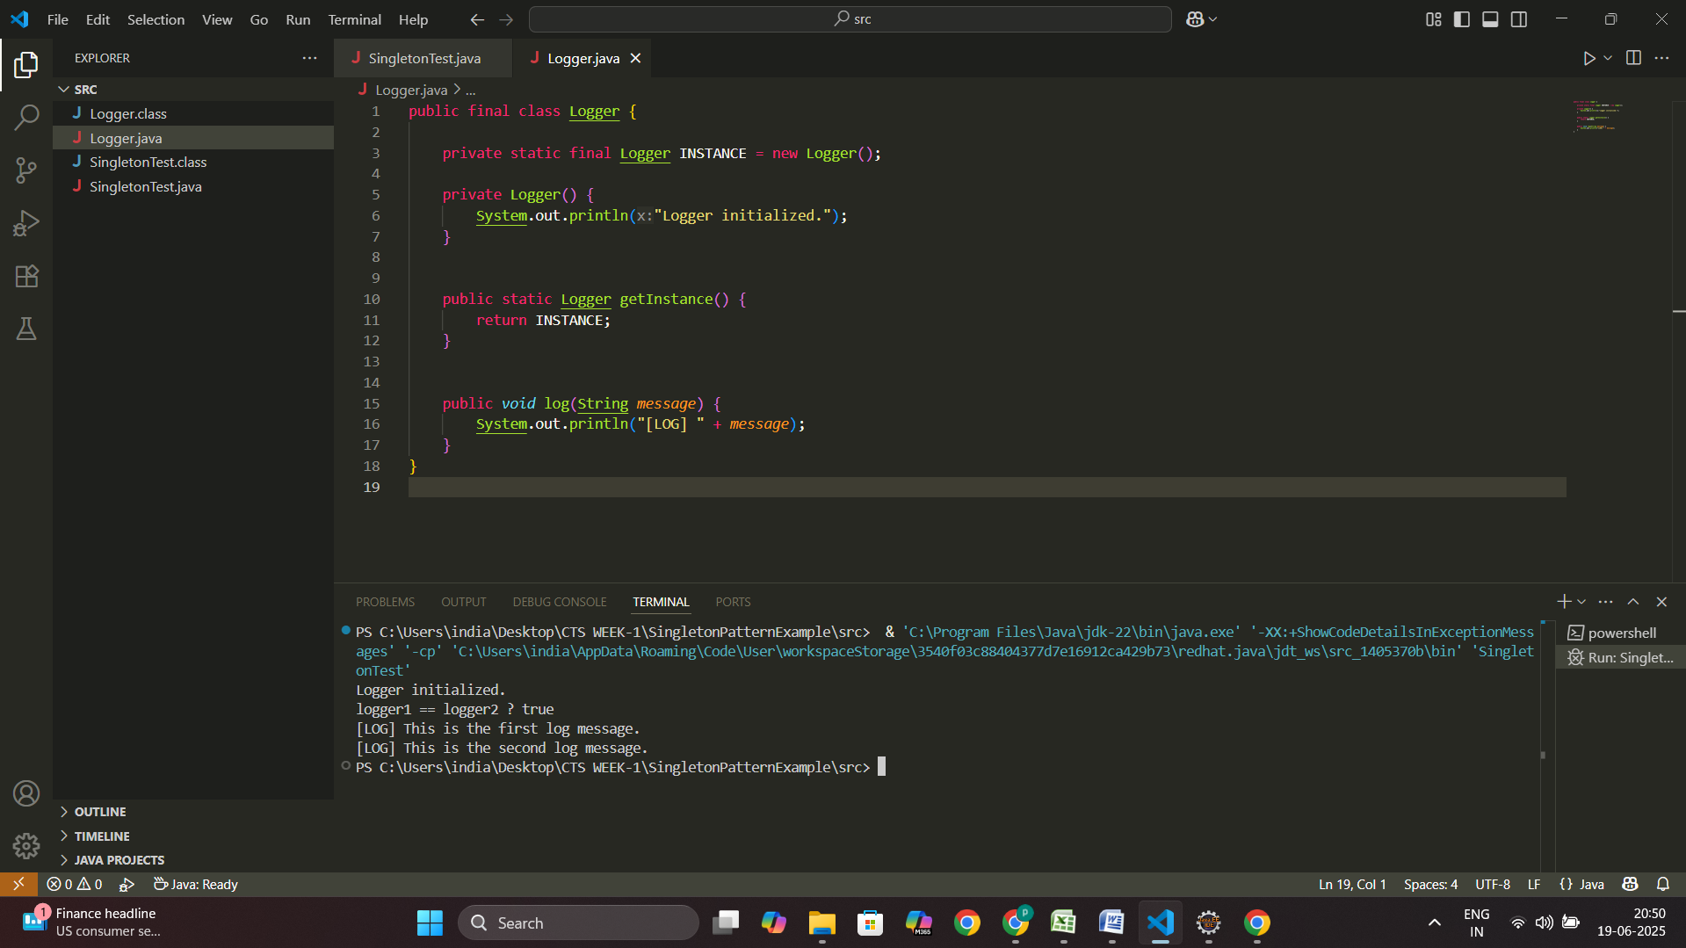you can see the out put above